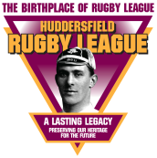 Theme 6

Hall of Fame

Pupil Resource Sheet 5

Albert Rosenfeld

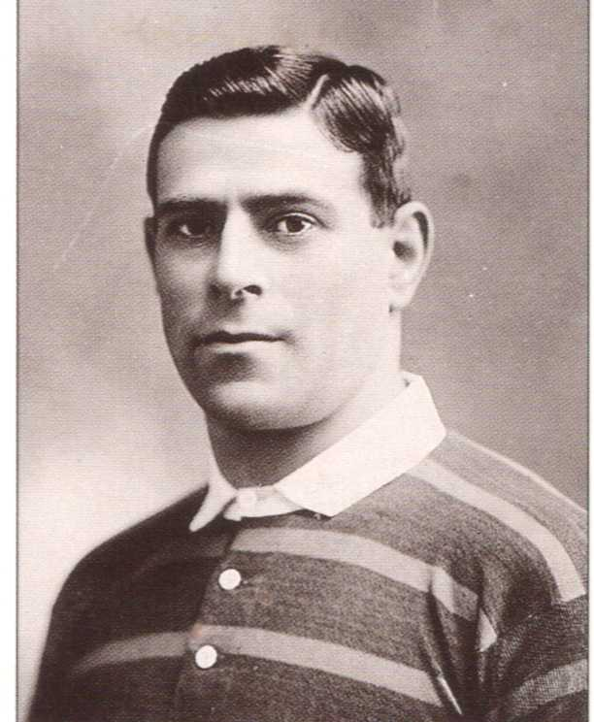

Albert Rosenfeld was born in Sydney, Australia, on 28th July 1885, into a Jewish family who had emigrated from Poland.

In 1900, aged 15, Albert began his working life as an apprentice tailor under his father.
Around the same time, he began to play rugby union for Eastern Sydney Borough.

In August 1907 the first ever Northern Union touring team, New Zealand, played three matches in New South Wales on their way to England. Albert played for New South Wales in the first of these matches, under rugby union rules. Along with his team mates, he was now banned from playing rugby union.

This sparked a rapid growth of the Northern Union game in New South Wales. Albert played for Eastern Suburbs in the very first northern union (rugby league) matches in Australia on 20th April 1908.

The New Zealanders called in to play three more matches on their way home from England. These were the first rugby league Test Matches played in the Southern Hemisphere. Albert played in all three and scored a try in the first, although New Zealand beat Australia 11-10.

By the time Eastern Suburbs played the first final in August 1908, Albert, now aged 23, was aboard HMS Macedonia on his way to England with the first Australian tourists.

Playing mainly at stand-off, Albert scored 5 tries in 15 tour matches, which included the second Test Match. After the Australian’s defeat at Huddersfield in February 1909, Huddersfield signed two of their players. One of them was Albert.

Albert had another reason for signing – he had fallen in love with a Huddersfield girl, Ethel. After a few months in Australia, Albert returned to Huddersfield and to Ethel in August 1909.
Australians’ first tour of England, 1908-09
Standing: Sid Pearce; J Jones; Dan Frawley; Albert Rosenfeld; Larry O’Malley;
Sitting: Dally Messenger

Huddersfield saw Albert as right winger. Although only 5 feet 6 inches tall, he weighed 12 stones. Strong and quick, he was brilliant at the short kick through and re-gathering the ball and was described as ‘the wary, nippery, slippery little Australian’ by the Huddersfield Examiner.

Albert made a great start, scoring two tries on his debut against Broughton Rangers in September 1909, but illness to the brilliant Harold Wagstaff saw Albert filling in at centre for much of his first season. He still managed 22 tries, a further 35 in 1910-11 and an incredible 78 in 1911-12, beating the previous best for a northern union season of 49. This included eight tries against Wakefield Trinity on Boxing Day 1911.

A further 56 tries followed in 1912-13, then in 1913-14 he set the record that still stands today of 80 tries in a season.

Albert’s left wing understanding and partnership with fellow Australian Tommy Gleeson was matched on the left wing by Wagstaff and Stanley Moorhouse, as Huddersfield became the greatest side that northern union had seen to that time.

Albert kicks inside during Huddersfield’s 9-5 won over Warrington in the 1913 Challenge Cup Final

In four seasons from 1912 to 1915 they won the Yorkshire Cup three times, the Yorkshire League four times, the Championship three times and the Challenge Cup twice.

They are best remembered as the ‘Team of All Talents’ that won all four trophies in 1914-15, a feat only ever achieved by two other clubs – Hunslet in 1908 and Swinton in 1928. Albert was again Huddersfield’s leading try-scorer.

There is no doubt that further glories would have come their way but for the outbreak of World War I. Assigned to the Army Service Corps, Albert played successfully for their rugby union team before being posted to Mesopotamia (Iraq). On his war service record he is called ‘Rosenfield’, probably an attempt to conceal his Jewish family roots which would have led to brutal treatment from the Germans had he been captured.

Although he won a regimental sprint cup in 1917, Albert returned from war service suffering from illness and heatstroke. He never regained his pre-war brilliance but still helped Huddersfield to win the Yorkshire League, Yorkshire Cup and Challenge Cup in 1919-20 before he was transferred to Wakefield Trinity in 1921.
From 1923 he played two seasons for Bradford Northern, before retiring from the game at the age of 38.

After that he coached amateur rugby at Rastrick, watched Huddersfield’s home games and followed the rugby league careers of his two grandsons.

Most rugby league players had another job as well as playing. Albert worked briefly as a tobacconist, but for many years drove the Huddersfield Corporation refuse cart and later, into his seventies, he was a dyer.

The Australians never forgot him. On every tour of England they gave him a special blazer with the words ‘pioneer’ on it. In 1964 Ethel and Albert celebrated their golden wedding by spending four months in Sydney, the first time Albert had been back in 55 years. They were treated like royalty wherever they went.

The last survivor of the pioneering Australian tourists of 1908, Albert died on 4th September 1970 in the Huddersfield home where he had lived for 60 years. He was 85.

In 1988 Albert was inducted as one of the first nine entrants to the Rugby Football League Hall of Fame.

Albert Rosenfeld: Playing Record
Team | Games | Tries | Goals | Points
Eastern Suburbs (Sydney) | 12 | 6 | 0 | 18
Australians (tour) | 14 | 5 | 0 | 15
Australia (tests) | 4 | 1 | 0 | 3
Huddersfield | 287 | 366 | 2 | 1102
Wakefield T | 66 | 16 | 1 | 50
Bradford N | 23 | 1 | 0 | 3
Colonial XIII | 2 | 3 | 0 | 9
Totals | 408 | 398 | 3 | 1200

Huddersfield NURFC 1914-15
Back: A Lee; JW Higson; H Banks; E Jones; E Heyes; F Longstaff; D Clark; A Swinden
Middle: A Bennett (trainer); R Habron; M Holland; S Moorhouse; H Wagstaff (captain); T Gleeson; G Todd; B Gronow; H Bennett (assistant trainer)
Front: Yorkshire League Cup; WH Ganley; Northern Rugby League Cup; AA Rosenfeld; Northern Union Challenge Cup; JH Rogers; Yorkshire Challenge Cup

